Redux with Hooks

What is Redux?
It helps to understand what this "Redux" thing is in the first place. What does it do? What problems does it help me solve? Why would I want to use it?
Redux is a pattern and library for managing and updating application state, using events called "actions". It serves as a centralized store for state that needs to be used across our entire application, with rules ensuring that the state can only be updated in a predictable fashion.

Why Should I Use Redux?
Redux helps us manage "global" state - state that is needed across many parts of our application.
The patterns and tools provided by Redux make it easier to understand when, where, why, and how the state in our application is being updated, and how our application logic will behave when those changes occur. Redux guides us towards writing code that is predictable and testable, which helps give us confidence that our application will work as expected.

When Should I Use Redux?
Redux helps us deal with shared state management, but like any tool, it has tradeoffs. There are more concepts to learn, and more code to write. It also adds some indirection to our code, and asks us to follow certain restrictions. It's a trade-off between short term and long term productivity.
Redux is more useful when:
- We have large amounts of application state that are needed in many places in the app
- The app state is updated frequently over time
- The logic to update that state may be complex
- The app has a medium or large-sized codebase, and might be worked on by many people
Not all apps need Redux. Take some time to think about the kind of app you're building, and decide what tools would be best to help solve the problems you're working on.

We

Pros and Cons of using Redux.
Pros
Makes state changes predictable and transparent we can easily see what is going on and how the application state changes in response to every action.
Centralizes our application state so all the data that our application needs is stored in a single place and is accessible by all parts of the UI.
Easily debug our application
We can easily cache or preserve the page state and
Implement undo and redo features
And we have a large ecosystem

Cons
Introduces complexity in our application this is because redux is based on functional programming principles and lot of developers are not familiar with the concept
Redux code tends to be verbose we have to write some boiler plate code to get things done.

When not to use redux.
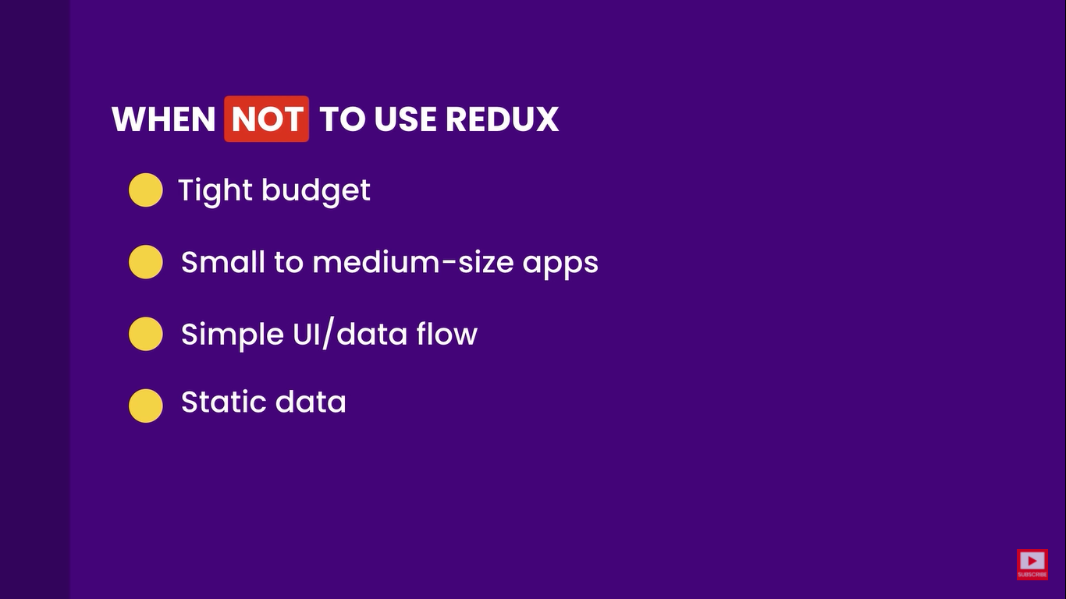

Redux Cycle
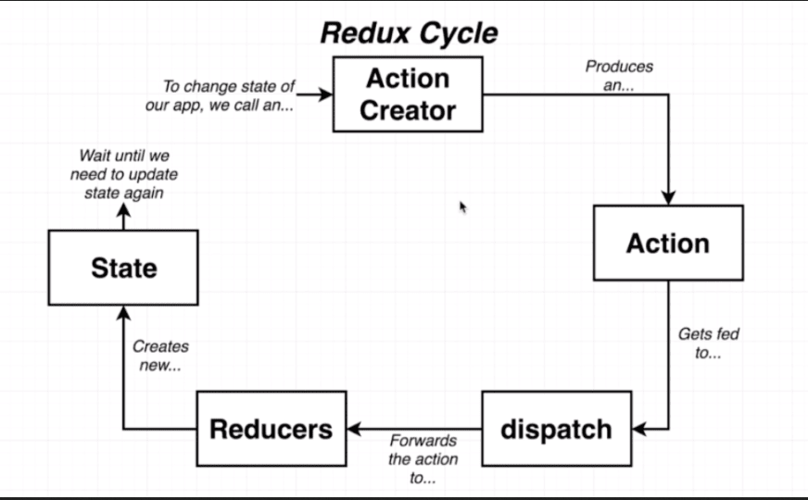

Context System
In context system we can communicate data from very high up parent down to some deeply nested child.
In order to communicate the information we create a context object.
Context object can be thought to be a pipe of sort which can move data directly from the parent to the deeply nested child.

Action creator: Action creator is a function that is going to return a plain javaScript object.
export const selectSong = (song) => {
//Return an action
return {
type: "SONG_SELECTED",
payload: song,
};
};

Action is this plain javaScript object. An action has a type property and a payload property
The type property of an action describes some change that we want to make inside of our data
The payload property describes some context around the change that we want to make
{
type: "SONG_SELECTED",
payload: song,
};

Dispatch: The dispatch is going to take this action and make copy of that object and pass it off to bunch of different places inside of our application.

Reducers: Reducer is a function that is responsible for taking in the action. With some existing amount of data it’s going to process that action and then make some change to that data and return it so that it can be centralized in some another location.
Every reducer gets two arguments
First the existing piece of data that belongs to this particular reducer
Second the action which is going to update the existing piece of data in the first argument.
const selectedSongReducer = (selectedSong = null, action) => {
if (action.type === "SONG_SELECTED") {
return action.payload;
}
return selectedSong;
};

When the reducer is called for the very first time we default the value of the state to null then it gets updated when we call the reducer next time with a action and payload the state gets updated until again the reducer is called.
We should keep in mind that any time we want change the state inside of the reducer we 100% of the time want to return a new array or a new object or a new string instead of modifying an existing one fir example to update the list of list of claims in a Claim history reducer we cant push action.payload in the existing array instead we need to use return […oldListOfClaims , action.payload]
Therefore we spread the state and , action.payload to update the array.

The Cycle:
Anytime we want to change the state or the data of our application we are going to call an action creator.
Calling an action creator is going to produce an action object this action object describes exactly how we want to change data inside of our application.
The action object gets fed to the dispatch function which in turn going to make copies of the action object and feed those copies to each of our different reducers.
The reducers are going to process those actions modify their data modify their data and eventually return some new data.
That data that gets returned gets formed into an new state object.
And then we wait until there is need to update the state object one more time.

The combine reducers call
The different reducers that we put together are simple functions all these simple functions need to be wired together
We wire up different reducers together by making use of combine reducers function.

Now the question is How do we get the state produced by the reducers and these action creators to be called inside our react components.
Using react-redux we create new components the provider and the connect
We create some instances of them and then we pass some props to both of the to configure exactly how they work

The store contains all the reducers and all the state with them of our application.
We are going to take that store that gets created and we will pass it as a prop into the provider.
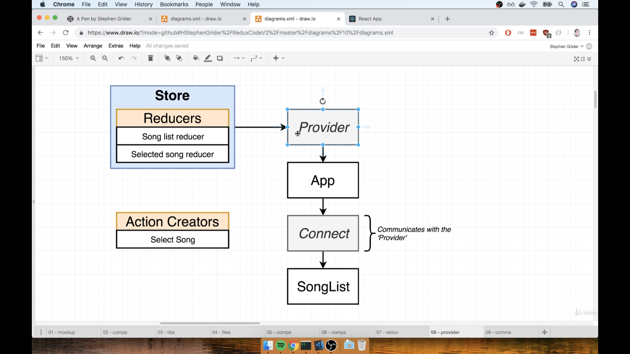
The provider is going to be rendered at very very top of our application hierarchy even above the app component.
We will show the app inside of the provider thing.
The provider is then going to have an internal reference to the store.
After wiring up this provider we then going to find every component inside of our application that needs to somehow access the data that is stored inside of our store.
The song list definitely needs to know about the list of song produced by the song list reducer.
For that we create an instance of the connect component right above the song list, we essentially wrap the song list component with this connect thing.
The connect component here is a very special component as it can communicate with the provider at the very top of our hierarchy it communicates with that provider not through the prop system but through a completely different system of communication inside of react called the context system. The context system allow any parent component to communicate directly with any child component even if there are other components between them.
The connect component is configured by us to keep track of the a state in one of our reducer and then communicate it back to the configured component with the change of state to rerender itself.

We also have action creators they are not stored in any way inside the store
Instead we call an action creator we take an action that is returned and we send it into store.dispatch function
That’s how we change data in the redux side of our application.

Once we start using react with redux the configuration changes a bit
We pass some more configuration into this connect component. In addition to telling it that we want to get a list of song we also gonna to tell the connect function that we want to be able to call the select song action creator from within our song list component.
The selectSong action is also sent to the SongList component as prop.
The connect function could be defined by importing connect from react-redux
And then at the export default call we export the component but this time after connect call like export default connect()(SongList)

To configure this connect component and tell it that we want to get some specific data out of redux store. We define a function right above our export default statement called mapStateToProps by convention.
It says that we are going to take our state object essentially all the data that’s inside of our redux store and we will run some computation on it that is going to show the data eventually as prop inside of our component.
This maps state to props is called with all of the state inside of our redux store the state will be our entire list of songs from the song list reducer and the currently selected song from the selected song reducer the state has all the data inside the redux store.
And after defining that function we pass it as first argument to the connect function downside
The mapStateToProps function will return an object of key of songs with value of state.songs..
Now the object that we returned inside the mapStateToProps will show inside as props inside our SongList component.

To access the action creator inside of the component we import it from the relevant folder and the pass it into the connect function
Therefore we spread the state and , action.payload to update the array.
const mapStateToProps = (state) => {
console.log(state);
return { songs: state.songs };
};
export default connect(mapStateToProps, { selectSong })(SongList);
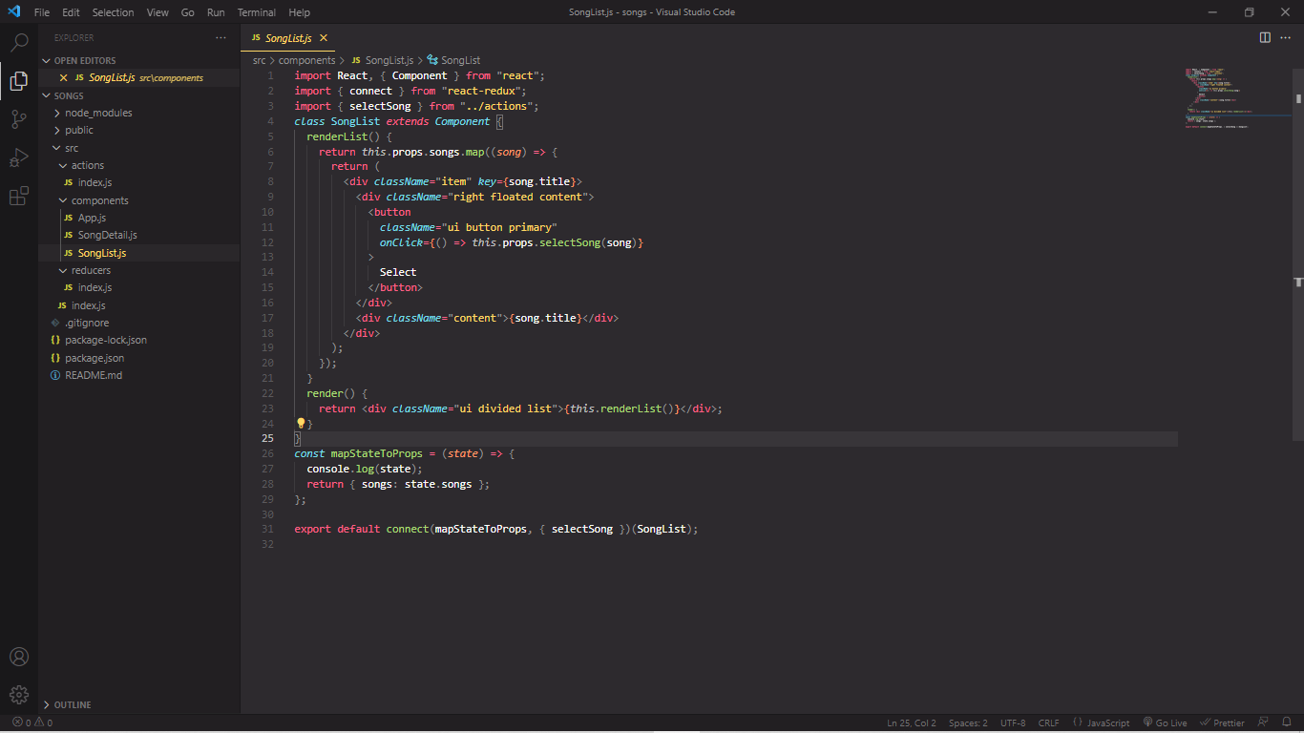
.
Async await with redux-thunk
import axios from "axios";

export default axios.create({
baseURL: "https://jsonplaceholder.typicode.com",
});

Above we have a axios request function
import jsonPlaceholder from "../apis/jsonPlaceholder";
export const fetchPosts = async () => {
const response = await jsonPlaceholder.get("/posts");

dispatch({ type: "FETCH_POSTS", payload: response });
};
And then we have our get type request where we want to get our posts and then the result of all that is assigned to response and then we take that response object and assign it to payload of our action object.

The above approach definitely looks like the correct thing we have an actionCreator it makes a request and it’s going to return an action object with our data on the payload property
But it’s a bad approach.
It’s not bad because it’s a bad design or we wrote the code incorrectly. It is because we are breaking the rules of redux we are specifically breaking the rules of an action creator.
When we run this code we get an error message actions must be plain objects.
Use custom middleware for async actions.

We use a middleware to help use make us request in a redux application.

But we need to understand first what’s really wrong with that action creator
Well in reality there are two things that are wrong.
- Action creator must return plain JS object with a type property we are not
- By the time our action gets to a reducer, we won’t have fetched our data

- Action creator must return plain JS object with a type property we are not and optionally a payload as well but at present we are not returning an action from an action creator.
It looks like we are returning an object with a type property but infact we are not.
Because any code that we are writing inside of our code editor is es6 and later syntax. The code gets trans-piled down to the 2015 syntax and that code is executed in the browser.
And in that we are not returning a plain JS object.
Because we specifically have the async await syntax here the entire function gets expanded to.
We can see down side our code has been expanded to a large chunk of code.

If we look at case 0 and case 2
If case 0 we return result of calling jsonPlaceholder.get("/posts")
And in case 2 we return something that looks like our object that we actually care about the action that we want to send to all of our different reducer
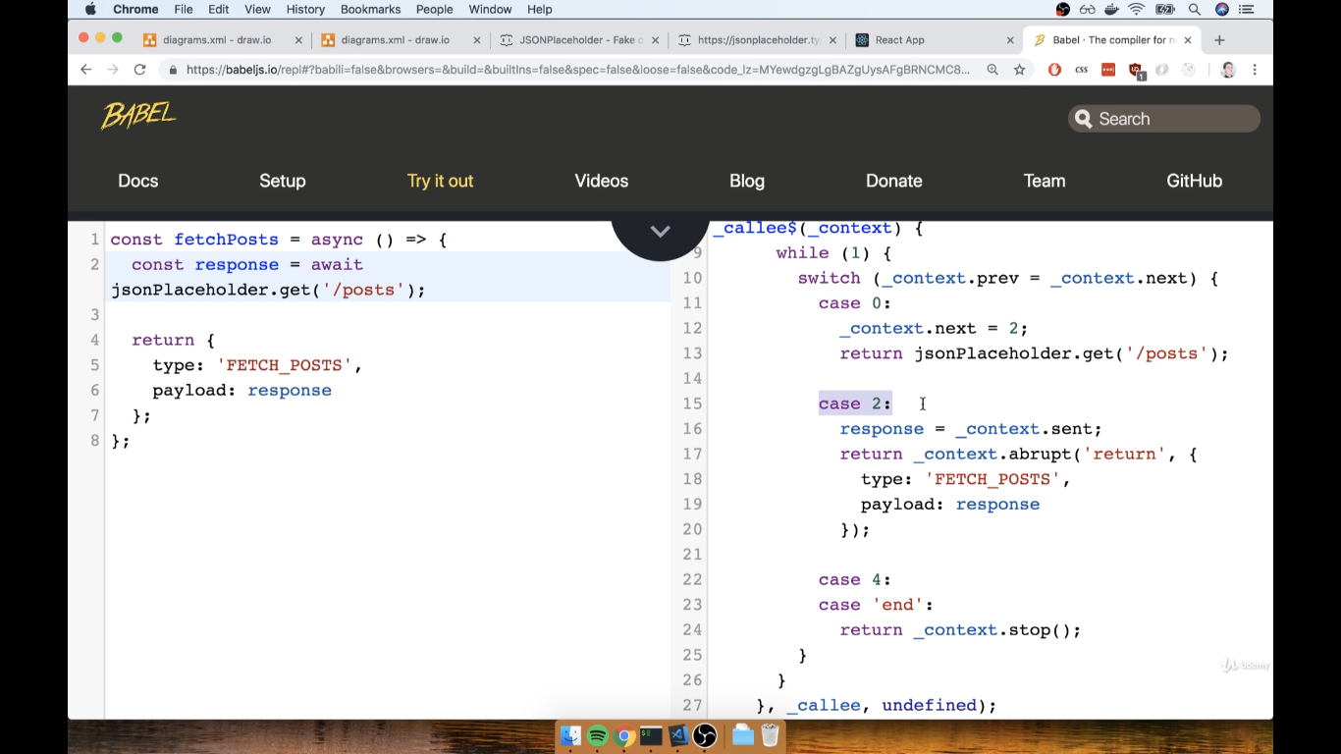

What we imagine that below scenario is probably applicably happening as the component gets rendered the component did mount method is called where we execute
this.props.fetchPost. And an action type is sent to our reducer in our store using our connect function. Now we have our payload from our fetch post action creator that will immediately dispatch the payload to the reducer and it will immediately be sent to the component via mapStateToProps and again using the connect function.

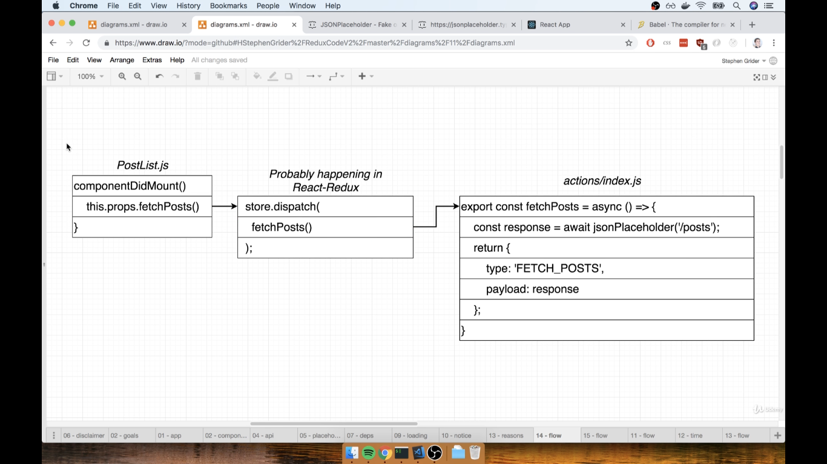

But that’s not the case at some point the execution is at point where we come to a line of code which says return jsonPlaceholder.get("/posts") so we return not our action object at first we return the case 0 not case 1 until case 1 is not ready to be returned
We return our request object and that goes to our reducer now the redux store says it’s not a plain JS object with only a type property
Well in this case no.
So we got the error message saying Actions must be plain objects use custom middleware for async actions.
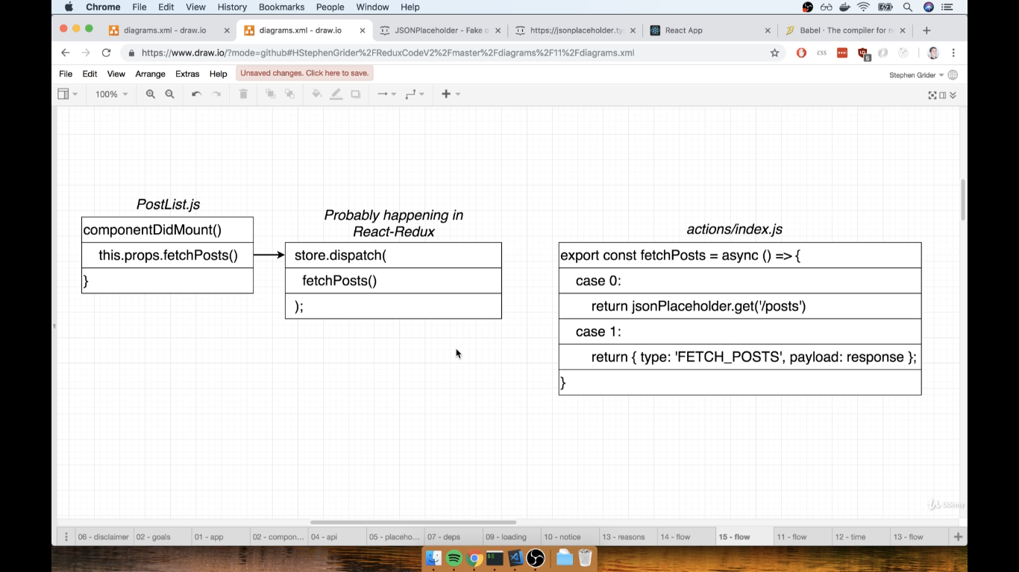
Above is the issue number one with our action creator

- By the time our action gets to a reducer, we won’t have fetched our data
We may ask what if we remove the async await syntax, without async await syntax we do not get data we get a promise object that is going to give access to our data when we eventually get it at some time
in future

export const fetchPosts = () => {
const promise = jsonPlaceholder.get("/posts");

dispatch({ type: "FETCH_POSTS", payload: response.data });
};

Above code will not give an error but will not work as we expect because as we might expect because By the time our action gets to a reducer, we won’t have fetched our data..

When we call an action creator and it returns the action and we dispatch it and it goes to our reducer all those steps are executed in a fraction of a fraction of a second.
This causes an issue for the fact that we are making an asynchronous request

Here on the left hand side is what happening inside redux and on right hand side what is happening with our request.
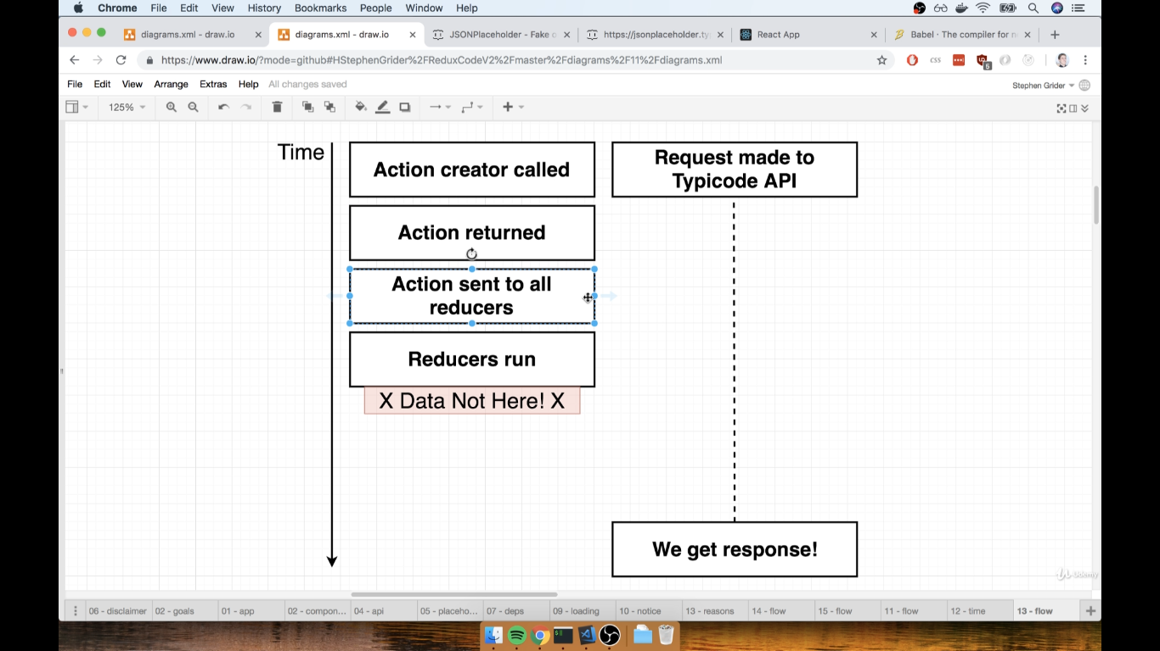
On the reducers side we cant delay them to wait for sometime before we get back the response.

We have to write asynchronous action creators
A synchronous action creator is one that when we call it immediately returns an actions object with all the relevant data attached to that object and is ready to be processed by a reducers.

An asynchronous action creator is one that is going to require a little bit of time before it is ready to eventually dispatch an action.
By definition any time we have an action creator that makes a network request it is always going to qualify as an async action creator.
For the purpose we install a middleware that is going us to allow with this asynchronous action creators.

So what is a middle ware.
We still will be calling our action creators that’s going to return an action that’s going to be dispatched
But now when we are going to dispatch an action rather than sending it all our reducers we are going to say that an action is going to be sent through all of the different middleware insides inside of our applications .
Inside of a redux app we can have as many as middleware as we want.
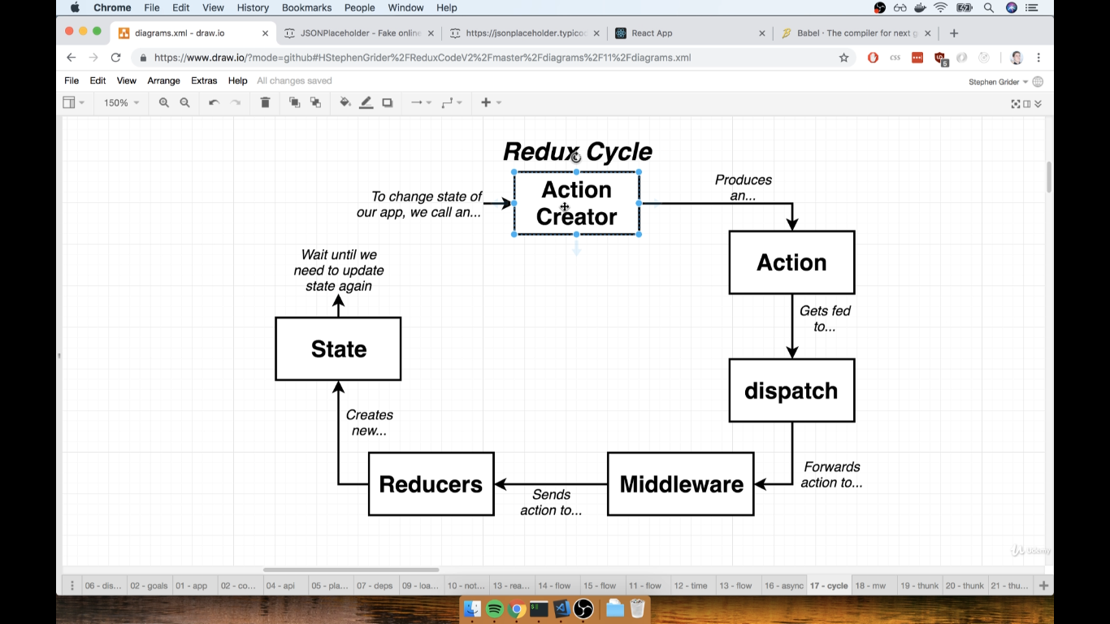

A middleware is a plain JS function that is going to be called with every single action that we dispatch.
Inside of that function the middleware has the opportunity to stop an action being dispatch so prevent it from going from any of our reducers
A middleware can modify an action it can mess around with an action in any way or shape that we can imagine.
We can very well write our own middleware and use them inside of our redux store

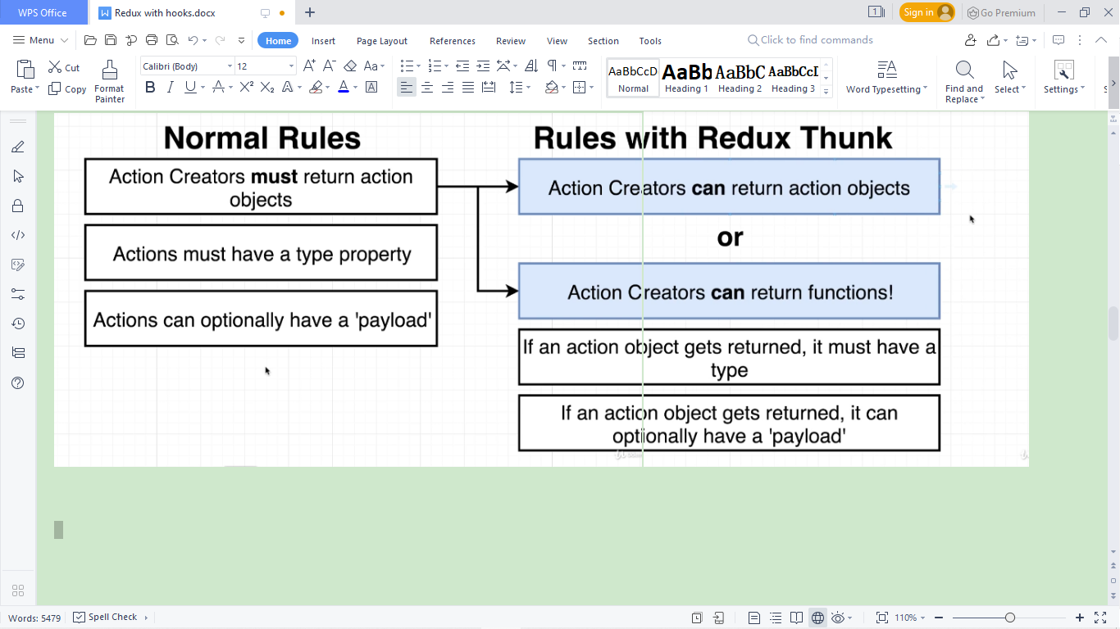

Inside of a normal redux application an action creator must return an action object.
That action object must be a plain JS object that has a type property and optionally can also have a payload as well.

How does redux thunk works
Redux thunk will essentially relax these rules here around an action creator.
Redux thunk will not have intrinsically built in function that says give me some request object and I will take It away from you.
Redux thunk an all purpose middleware that allows us to deal with asynchronous action creators but it also allows us do many other things as well.

Redux thunk makes only change to our action creator rules is that
Our action can return an action object. If we return an action object it still must have a type property and if it’s the action object that gets returned it can optionally have an action payload as well.
The other thing that redux thunk does is that it allow us to return either action object or a function.
And if we return a function redux thunk can automatically call that function for us. That is all redux thunk does

export const fetchPosts = () => {
return function () {
const promise = jsonPlaceholder.get("/posts");

dispatch({ type: "FETCH_POSTS", payload: response.data });
};
};

Basically we can return a function that is going to have some logic inside of it.
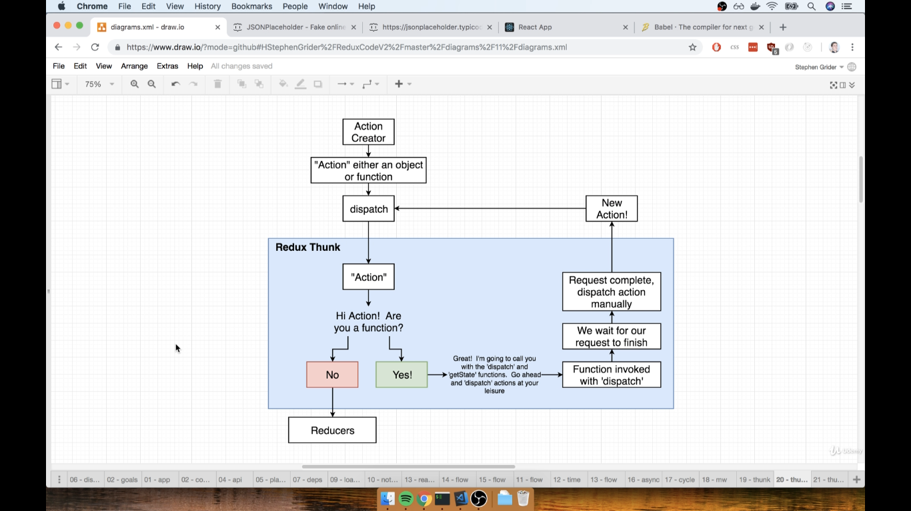
when we call an action creator, our action creator is going return an action (object or function) we will take that and pass it into dispatch function.
After dispatch it ends up in redux thunk.
Redux thunk will look at that something function or object and ask are you a function or are you an object,
If something is object Redux thunk will pass it down to the different reducers
If something is a function instead redux thunk will invoke that function and pass into it the dispatch and getState functions as arguments
export const fetchPosts = () => {
return function (dispatch, getState) {
const promise = jsonPlaceholder.get("/posts");

dispatch({ type: "FETCH_POSTS", payload: response.data });
};
};

With the function that we are going to return we are going to receive dispatch and getState as arguments. Now the dispatch function is the same dispatch function that we can pass the actions into.
Those actions are going to be sent with all our middleware and eventually forwarded to our reducers.
Dispatch function is essentially unlimited power to initiate changes to the data on the redux side of our app..
getState can be called on our redux store and that will return all the data and all the state inside of our redux store.
So these two arguments that our function receives are essentially unlimited power over everything that goes inside of our redux application.
Through dispatch we can change any data that we want and through getState we can access any data that we want
With above code we are trying to make a request inside our function. Redux thunk will invoke our function with those two arguments. Inside our function we will code to wait for the request to finish with some async syntax until we eventually get a response from our api. Once we get that response we will use that dispatch function to manually dispatch an action.
So when we dispatch an action we get an new action which can again be a plain JS object or a function but after dispatching it will always going to be a plain object.
We will dispatch that action it is going to flow back to the dispatch, it will send us right to the redux thunk redux thunk will pass it to the reducer as it is an object.

import _ from "lodash";
import jsonPlaceholder from "../apis/jsonPlaceholder";
export const fetchPostsAndUsers = () => async (dispatch, getState) => {
await dispatch(fetchPosts());
const userIds = _.uniq(_.map(getState().posts, "userId"));
userIds.forEach((id) => dispatch(fetchUser(id)));
};

export const fetchPosts = () => async (dispatch) => {
const response = await jsonPlaceholder.get("/posts");

dispatch({ type: "FETCH_POSTS", payload: response.data });
};

export const fetchUser = (id) => async (dispatch) => {
const response = await jsonPlaceholder.get(`/users/${id}`);

dispatch({ type: "FETCH_USER", payload: response.data });
};

Rules for Reducers
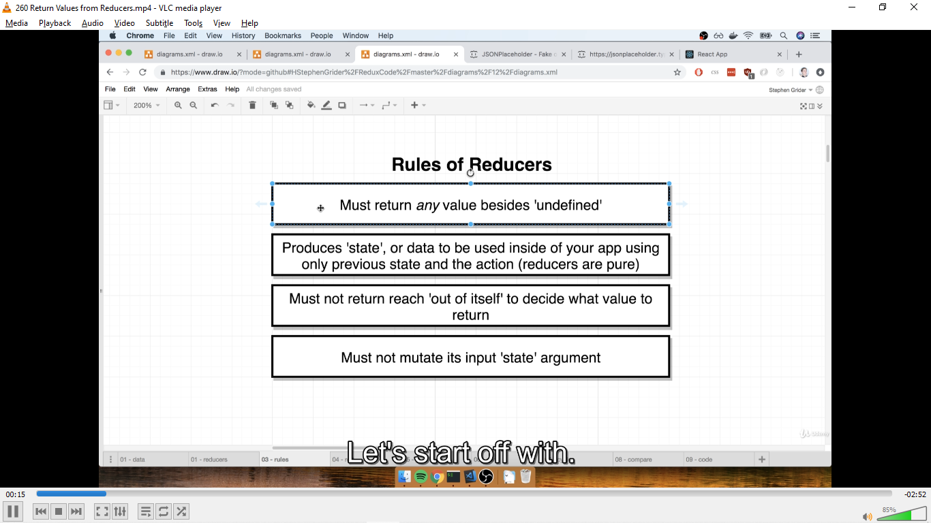

- It must return any value besides undefined. The rule in not only during initialization a reducer can never return undefined
- Reducers are supposed to produce or return state or data that is going to be used inside of our application and the reducer has to do so only using the previous state the last time that it was
called and the action object that has been dispatched and is being passed into a given reducer
When we start our application each reducer will be automatically called one time. This automatic invocation allows the reducer to specify some default state value.
First time the reducer gets called during that initialization process it is going to receive two arguments.
The first argument is going to have a value of undefined and then the second argument will be some action object that we might refer to as action #1 because it is the first action that the reducer is going to see
So it is then up to the reducer to take that two arguments and return a some initial state value.
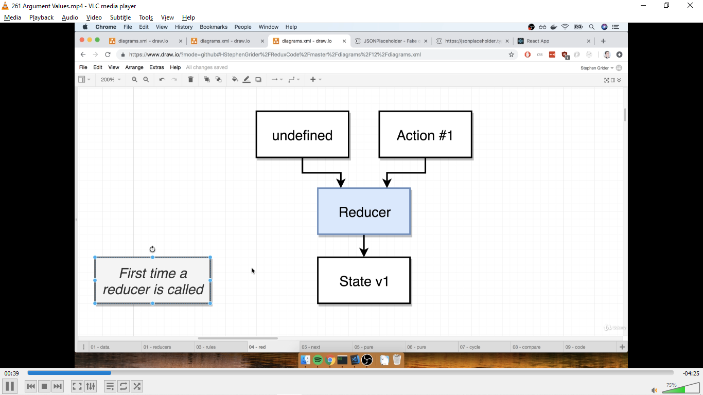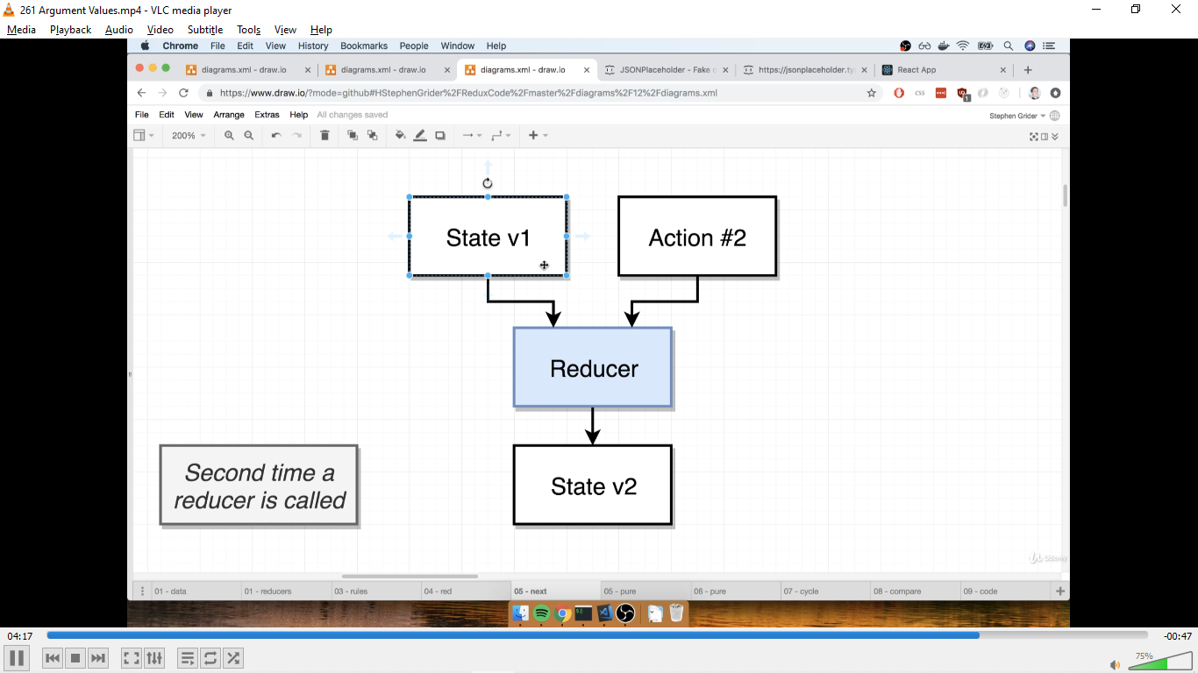

const selectedSongReducer = (selectedSong = null, action) => {
if (action.type === "SONG_SELECTED") {
return action.payload;
}
return selectedSong;
};
When the application first started up the selectedSongReducer was invoked automatically one time.
So redux did something internally like selectedSongReducer whose first argument was undefined and the second argument was some initialization object we don’t know what type that this action is going to have.
selectedSongReducer(undefined,{})
Here the first argument is undefined that’s why we put a default value for selected song that is null. This default value will only be put by the reducer very first time when it is called.

When reducer is called for the second time and onwards the first argument will no longer will be the value of undefined instead it’s going to be whatever the reducer returned the last time that it was ran.
In diagram when the reducer ran for the first time it returned State v1.
The second time when the reducer is called the first argument will be state v1
Reducer gets called with its own value that it returned over and over again. The only change we are doing is the action object.

- A reducer must not reach outside of it’s function to decide what value to return.
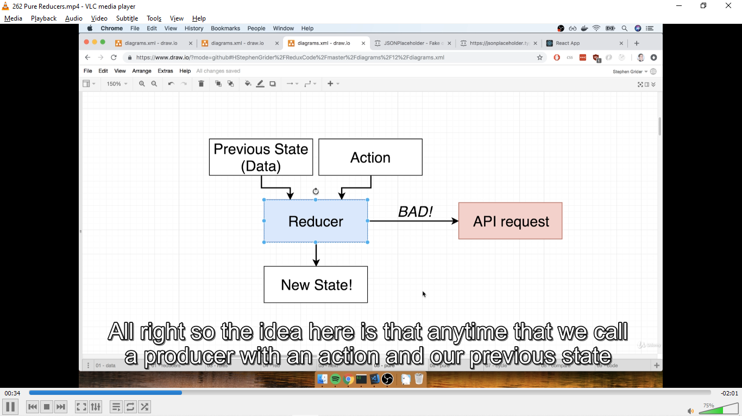
Any time that we call the reducer with an action and previous state value we are not supposed to reach our of this function what so ever.
We are not supposed to make an API request or try to read some file out of hard drive.
When a reducer gets called it’s only going to look at its initial state value and the action object to decide what to return.
The only thing that we can return is doing some computation done on the two argument

- By convention we refer to first argument of our reducer as state because that’s what it really is. It is a piece of state that the reducer is managing from the last time the reducer ran
The 4th rule says do not mutate it’s input state argument
This rule is extremely misleading and possibly even false

let hasChanged = false
const nextState: StateFromReducersMapObject<typeof reducers> = {}
for (let i = 0; i < finalReducerKeys.length; i++) {
const key = finalReducerKeys[i]
const reducer = finalReducers[key]
const previousStateForKey = state[key]
const nextStateForKey = reducer(previousStateForKey, action)
if (typeof nextStateForKey === 'undefined') {
const actionType = action && action.type
throw new Error(
`When called with an action of type ${
actionType ? `"${String(actionType)}"` : '(unknown type)'
}, the slice reducer for key "${key}" returned undefined. ` +
`To ignore an action, you must explicitly return the previous state. ` +
`If you want this reducer to hold no value, you can return null instead of undefined.`
)
}
nextState[key] = nextStateForKey
hasChanged = hasChanged || nextStateForKey !== previousStateForKey
}
hasChanged =
hasChanged || finalReducerKeys.length !== Object.keys(state).length
return hasChanged ? nextState : state
}
}

Above we have some code chunk from redux library source code specifically from combinedReducer.js last 25 lines.
This code is going to take any time that it get’s dispatched and send the action around to all the reducers inside of our applications .
In other words every time that we dispatch an action this code gets executed

First up a variable is set when we dispatch an action an is set equal to false
Then we enter a for loop this for loop iterates over all the reducers, inside of the body of the for loop we have a variable called previousStateForKey this variable is assigned the last state value the reducer returned.
Next we have reducer(previousStateForKey, action) here we invoke the reducer which has the first argument the state value that the reducer last time returned thepreviousStateForKey and the second argument is the action object.
The reducer will run and return some new value which is assigned to nextStateForKey.
Then we have a conditional statement where is the nextStateForKey is undefined if it is then we have an error message as in the code.
If the check is passed then we have
nextStatei is assigned the nestStateForKey value and in the next line we have
hasChanged = hasChanged || nextStateForKey !== previousStateForKey
hasChanged is equated to hasChanged which is set to false or the check for whether nextStateForKey !== previousStateForKey
This check is to see if nextStateForKey and previousStateForKey are the exact same array or object in memory.
So if we returned some array and it is the exact same array in memory that we returned the last time that this reducer ran then has changed is going to be a value of false other wise if reducer ran and returned a brandnew array completely just created inside of the reducer than has change will be set equal to true
If any reducer has returned a new value or a new object or a different value for an integer or a string has change is set to true.
Then with return hasChanged ? nextState : state we look at the value of hasChanged.
If has changed is equal to true the result of entire function is returned the newState the new state assembled by all our reducer other wise if hasChanged is equal to false we instead return false.
We instead return state which is a reference to all the state that our reducer the last time that they ran.
So the reason we care so much about not mutating the state is not because we can’t state argument that’s not the case. The reason we say this because if we accidentally returned the same value that is pumped in to our reducer redux will detect no difference in the array or the memory so no updates done the react app does not to rerender itself so we will not see any updated content on the screen.

X`
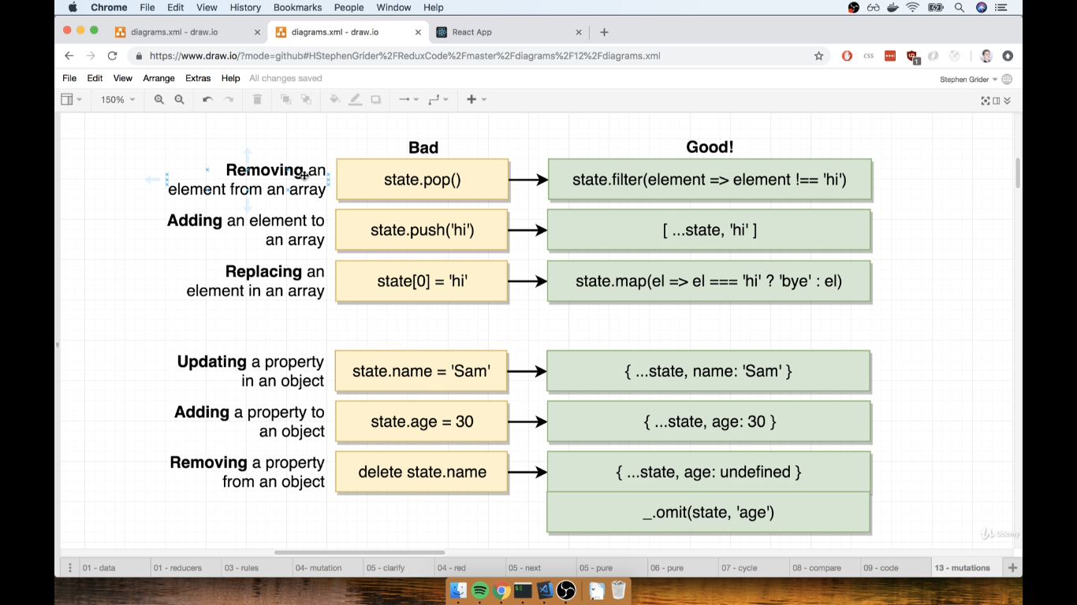

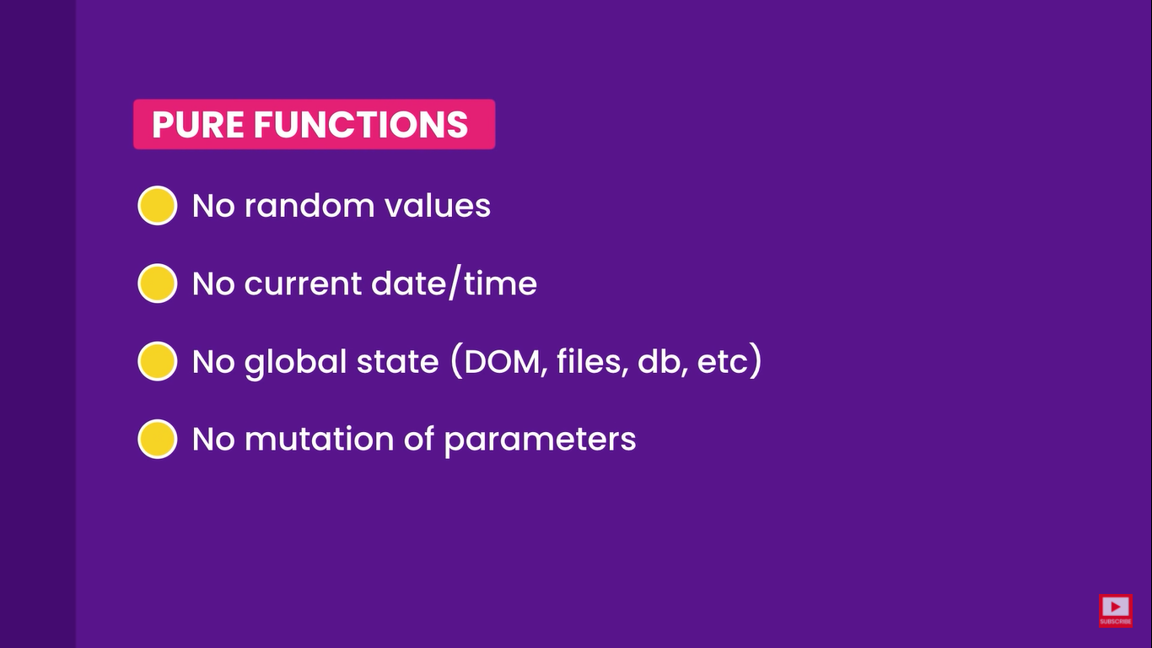

function isEligible (age){
return age> minAge;
}

Above we have an impure function ie every time we have the same input it will not give the same result.
The result will depend on minAge which can be changed for a given age.
function isEligible (age, minAge){
return age> minAge;
}

But above we have a pure function for a given set of age and minAge this function is going to give the same result .

Benefits of pure functions
- Self Documenting these functions are self documenting because every thing that a function need is specified in as parameter
- This makes this function easier to test becaue we don’t have to set some global set prior to testing these function
- Because we don’t use global state or change it we can run this functions in parallel
- They are cacheable as they are pure we can store the result in the cache and use it in the future, this is useful if the functions have intensive computation,

immutability
Once created , cannot be changed!
If we want to change the object we have to take the copy first and change that copy.
For example string in javascript and in most programming language are immutable.
But if we have object we can change or mutate the object directly so in javascript array and objects are not immutable that’s why javascript is not a pure functional programming language.
In pure functional programming language we cannot mutate data.

What about the const keyword
When we are using const we are not creating a immutable object.
const book = {};
book.title =”…”;
We can declare book as constant and then we can change it’s title property
With const we cannot reasign book to different object.
So const prevent reasignment

Why immutability
It makes our application more predictable. If we call a function and pass an object to it we know that object is not gonna change so there are no surprises down the road
It makes faster to detect changes we know that react needs to know that the state has changed so that it can trigger rerendering.
For example lets say that we have book object stored in memory location 100. with immutability to change the property of this object we have to create a new object. This object is gonna be stored in different location in memory lets say 200. now react can quickly tell if the object has been modified because react compares these object with references.
It’s like comparing 100 with 200. this is a very fast operation.
In contrast if we don’t use immutability react has to compare every property of an object to see if its changed so immutability makes change detection faster

And the third benefit of immutability is concurrency
If we know that a function does not mutate data we know that we can safely run this function in parallel its not gonna change something in memory

Hooks Way
React's new "hooks" APIs give function components the ability to use local component state, execute side effects, and more. React also lets us write custom hooks, which let us extract reusable hooks to add our own behavior on top of React's built-in hooks.

React Redux includes its own custom hook APIs, which allow your React components to subscribe to the Redux store and dispatch actions.

Using Hooks in a React Redux App
As with connect(), you should start by wrapping your entire application in a <Provider> component to make the store available throughout the component tree:

const store= createStore(rootReducer)

ReactDOM.render(
<Provider store={store}>
<App/>
</Provider>,
document.getElementById('root')
)

From there, you may import any of the listed React Redux hooks APIs and use them within your function components.

useSelector()
const result: any = useSelector(selector: Function, equalityFn?: Function)
Allows us to extract data from the Redux store state, using a selector function.
The selector is approximately equivalent to the mapStateToProps argument to connect conceptually. The selector will be called with the entire Redux store state as its only argument. The selector will be run whenever the function component renders (unless its reference hasn't changed since a previous render of the component so that a cached result can be returned by the hook without re-running the selector). useSelector() will also subscribe to the Redux store, and run your selector whenever an action is dispatched.

However, there are some differences between the selectors passed to useSelector() and a mapState function:

- The selector may return any value as a result, not just an object. The return value of the selector will be used as the return value of the useSelector() hook.
- When an action is dispatched, useSelector() will do a reference comparison of the previous selector result value and the current result value. If they are different, the component will be forced to re-render. If they are the same, the component will not re-render.
- The selector function does not receive an ownProps argument. However, props can be used through closure or by using a curried selector.
- Extra care must be taken when using memoizing selectors.
- useSelector() uses strict === reference equality checks by default, not shallow equality.

INFO
There are potential edge cases with using props in selectors that may cause issues. Refer to usage warning below
Therefore we spread the state and , action.payload to update the array.
We may call useSelector() multiple times within a single function component. Each call to useSelector() creates an individual subscription to the Redux store. Because of the React update batching behavior used in React Redux v7, a dispatched action that causes multiple useSelector()s in the same component to return new values should only result in a single re-render.
Equality Comparisons and Updates
When the function component renders, the provided selector function will be called and its result will be returned from the useSelector() hook. (A cached result may be returned by the hook without re-running the selector if it's the same function reference as on a previous render of the component.)
However, when an action is dispatched to the Redux store, useSelector() only forces a re-render if the selector result appears to be different than the last result. As of v7.1.0-alpha.5, the default comparison is a strict === reference comparison. This is different than connect(), which uses shallow equality checks on the results of mapState calls to determine if re-rendering is needed. This has several implications on how you should use useSelector().

With mapState, all individual fields were returned in a combined object. It didn't matter if the return object was a new reference or not - connect() just compared the individual fields. With useSelector(), returning a new object every time will always force a re-render by default. If you want to retrieve multiple values from the store, you can:

Call useSelector() multiple times, with each call returning a single field value
Use Reselect or a similar library to create a memoized selector that returns multiple values in one object, but only returns a new object when one of the values has changed.
Use the shallowEqual function from React-Redux as the equalityFn argument to useSelector(), like:

import { shallowEqual,useSelector } from "react-redux";

// Later
const selectedData = useSelector(selectorReturnigObject, shallowEqual)

Examples

import React from 'react'
import { useSelector } from "react-redux";

export const CounterComponent = ()=>{
const counter = useSelector((state)=>state.counter)
return<div></div>
}

Using props via closure to determine what to extract.

useSelector() will also subscribe to the Redux store, and run your selector whenever an action is dispatched.
However, there are some differences between the selectors passed to useSelector() and a mapState function:

Implementation
We create a store.js file where we
import { createStore } from "redux";
And export a constant called store equals createStore which takes a single argument called reducer.
export const store = createStore(reducer);

Reducer functions are key to redux

function reducer(state, action) {
return state;
}

The reducer function is similar to arrays reduce function where the state represents the previous state of the world and the action represents the current action being processed
Reducer always returns a new state or an old state it never modifies the state.
In order to our reducer to be some what useful we need to provide with some state
We do that with a variable called initial state. And we give it the relevant state and the initial value for the application.
To use the initial state we can say state = initialState

import { createStore } from "redux";

const initialState = {
amount: "12.00",
currencyCode: "USD",
};

function reducer(state = initialState, action) {
return state;
}
export const store = createStore(reducer);

Now that we have our redux store set up we need to tell our application about it
In our index.js we
import { Provider } from "react=redux";
import { store } from "./stores";
And then we wrap our app component with provider component here it’s exchange rate component
import React from "react";
import ReactDOM from "react-dom";
import { Provider } from "react=redux";
import { store } from "./stores";
import { ExchangeRate } from "./components/ExchangeRate";
import "./style.css";

ReactDOM.render(
<Provider store={store}>
<ExchangeRate />
</Provider>,
document.getElementById("root")
);

Now all the component inside of our application have access to our redux store.

Now inside our components file like here we have ExchangeRate.js we
import { useSelector } from "react-redux";
And inside of the component to access the state
We type
const amount = useSelector((state) => state.amount);
const currencyCode = useSelector((state) => state.currencyCode);
The useSelector hook takes a function which receives as its first argument state and then allows it us to return from that which part of state do we want.
So our useSelector hook takes the full state and returns state.amount and state.currencyCode and any time those values are updated within our redux store this component will be automatically rerendered.
With redux we don’t use setAmount and setCurrencyCode
What we have is action creators
And in our fields we use dispatches
For that we import useDispatch from react-redux.
And top of our function declaration type
import { useDispatch } from "react-redux";
const dispatch = useDispatch();

useDispatch is a function that allows us to send actions into our reducers those actions will potentially update the state.
In our onChange function
function onChange(e) {
dispatch({ type: "amountChange", payload: e.target.value });
}
Here we have an onChange function that takes in e for event and dispatches our action object{ type: "amountChange", payload: e.target.value } using dispatch created with useDispatch hook.
The action object has type amountChange and payload e.target.value the value corresponds to the value we change in our input fields.
So every time we type in to our field we gonna dispatch the amountChange into our reducer.

Inside our store.js which has our only reducer
We write
function reducer(state = initialState, action) {
if (action.type === "amountChange") {
return { ...state, amount: action.payload };
}
return state;
}
With redux and react in general we don’t modify the state we always work with immutable one way data
In this case we don’t modify the existing state we create a new state object using the existing state as the basis for our copy and in the new object we override the amount field with action.payload which is the new amount coming from our dispatched amountChange action any time that event is dispatched we are updating the entire state in our reducer to new state with a new amount.
Same thing we will do with the handle currency code.

Multiple reducers and combineReducers function

Lets have a store folder in which we would have our stores.js
And lets extract the code for our only reducer to the ratesReducer.js
const initialState = {
amount: "12.00",
currencyCode: "USD",
};
export function ratesReducer(state = initialState, action) {
switch (action.type) {
case "amountChanged":
return { ...state, amount: action.payload };
case "currencyCodeChanged":
return { ...state, currencyCode: action.payload };
default:
return state;
}
}

And lets create a user reducer
const initialState = {
name: "Manyu",
loggedIN: false,
};
export function userReducer(state = initialState, action) {
return state;
}

Now the reducer is splitup to two reducers
Now we need to join them together in our stores.js
For that we import combineReducer along side createStore
import { createStore, combineReducers } from "redux";
And also

And inside of createStore method we will passin combineReducer and that’s going to take an object where we can addin our reducers with a key to namespace them.
We will have userReducer with the key of user
And ratesReducer with the key of rates.

import { createStore, combineReducers } from "redux";
import { userReducer } from "./user";
import { ratesReducer } from "./rates";
export const store = createStore(
combineReducers({
user: userReducer,
rates: ratesReducer,
})
);

Now one thing is not that obvious here as we combine these reducers is that our data is now going to be stored in the namespaces the user data under user and rates under rates
So anytime we are accessing something like state.amount is now gonna be accessed at state.rates.amount
Similarly state.name gonna be accessed at state.user.name.

It’s also a common practice when we split a reducer to standardize the naming convention of our actions
We need to change it to rates/amountChanged and rates/currencyCodeChanged.

Selector Functions API for Accessing Redux data.
As our data becomes spread across multiple reducers. It becomes important to standardized how we access that data.
Ultimately each slice of our redux store owns how that data is named or stored.
Its convenient to provide selector functions as a public interface to that data.
Inside of store.rates.js
We will create a new section at bottom called selectors
// selectors
export const getAmount = (state) => state.rates.amount;
export const getCurrencyCode = (state) => state.rates.currencyCode;

We do the same in user.js

Inside of our components like RateTable.js
We
import { useSelector } from "react-redux";
import { getName } from "../store/user";
And then at the top of the rateTable component
const name = useSelector(getName);

With this we have access to name inside of our RateTable.js
This gives us convenience that if we want to update our selector in the slice itself and we don’t need to go around the entire application to update the path.
Its also nice if we want to do something more with the selector for example if we wanted to return just the first name
So we can write fullname.split(“ “)[0].toLowerCase() or whatever additional thing we want to do with my selector we can do it in one place rather than doing it all through our the application

Refactor to use action type constants and action creators when dispatching redux actions

Inside of our rates.js
We can add
// action types
export const AMOUNT_CHANGED = "rates/amountChanged";
export const CURRENCY_CODE_CHANGED = "rates/currencyCodeChanged";

Then in our reducers we can add constants instead of hard coded strings and because we are exporting them anywhere in our application where we are dispatching actions
We can simply import the AMOUNT_CHANGED and CURRENCY_CODE_CHANGED action type constants and use where we dispatch the action
It does not buy a value but lets use avoid some typo

A far more helpful pattern is something called action creators
So in our store in our rates.js
We create new section called
// action creators
export const changeAmount = (amount) => ({
type: AMOUNT_CHANGED,
payload: amount,
});

export const changeCurrencyCode = (currencyCode) => ({
type: CURRENCY_CODE_CHANGED,
payload: currencyCode,
});

And action creator is a function which takes in some data and then returns a well formatted action object which can be expected in our reducers
So in our amount field instead of importing AMOUNT_CHANGED
We import changeAmount and then dispatch(changeAmount(e.target.value));
dispatch(changeCurrencyCode(e.target.value));

Async acitons with redux thunk
In our store.js
import thunk from "redux-thunk";

And we also import an additional method from redux applyMiddleware
import { createStore, combineReducers, applyMiddleware } from "redux";

applyMiddleware is used as the second argument to the creatStore function and passin to it thunk
import { createStore, combineReducers, applyMiddleware } from "redux";
import { userReducer } from "./user";
import { ratesReducer } from "./rates";
import thunk from "redux-thunk";
export const store = createStore(
combineReducers({
user: userReducer,
rates: ratesReducer,
}), applyMiddleware(thunk)
);

We have now setup redux-thunk.
Now in our exchangeRate we can comment out useEffect hook
And we get currency data with our selector
const currencyData = useSelector(getCurrencyData);

And in our rates.js we will create our getCurrencyData selector
export const getCurrencyData = (state) => state.rates.currencyData;
And we will set our initial state for currency data
const initialState = {
amount: "12.00",
currencyCode: "USD",
currencyData: { USD: 1.0 },
};

Now we need to make our API call
For that we will update our changeCurrency code action creators and instead of returning a object we will return a function with single argument of dispatch and inside of that function body we can add dispatch our currencyCode action
export const changeCurrencyCode = (currencyCode) => (dispatch) => {
dispatch({
type: CURRENCY_CODE_CHANGED,
payload: currencyCode,
});
};

Now we gonna make our API call
For that we import getExchangeRate from our ./api
And then inside of our change currency code after the manual dispatch for the getting the currency code
We use the getExchangeRate function the first argument is the the currency code.
And the second argument called supportedCurrencies which we need to bring it from the exchangeRate.js
As we get our exchange rates from the api we dispatch another action
{
type: RATES_RECEIVED,
payload: rates,
}
Now the reducer needs to be updated as we have new action that can change the state
export const changeCurrencyCode = (currencyCode) => async (dispatch) => {
dispatch({
type: CURRENCY_CODE_CHANGED,
payload: currencyCode,
});
const rates = await getExchangeRates(currencyCode, supportedCurrencies);
dispatch({
type: RATES_RECEIVED,
payload: rates,
});
};

Now the reducer needs to be updated as we have new action that can change the state
export function ratesReducer(state = initialState, action) {
switch (action.type) {
case AMOUNT_CHANGED:
return { ...state, amount: action.payload };
case CURRENCY_CODE_CHANGED:
return { ...state, currencyCode: action.payload };
case RATES_RECEIVED:
return { ...state, currencyData: action.payload };
default:
return state;
}
}

Now the application works the same as when we had the useEffect hook.
When we had the useEffect hook incharge of making our exchange rate call it would happen immediately on app load.
Our new approach only fires when we change the exchange rate.

To set the functionality we need to set the function we need to use changeCurrencyCode actioncreator in our use effect and dispatch it on initial render.
For that we will import the useDispatch and useEffect hook inside of our ExchangeRate.js file
We also import the changeCurrencyCode action creator

useEffect(() => {
dispatch(changeCurrencyCode);
// getExchangeRates(currencyCode, supportedCurrencies).then((rates) => {
// setCurrencyData(rates);
// });
}, []);

Now lets recap what happened

We introduced a new library called redux-thunk which is a redux=middleware that add support for asynchronous action creator using thunks.
A thunk is basically a function that returns another function.
We use one of these in the change currency code which returns a function that receives a dispatch function as its argument and calls it when currencyCode is changed and after our exchange rates comes back.
When our rates are received our rates reducer stores them for us and we access that in exchangeRate.js with the useSelector hook
Finally to kickoff our exchangeRates call at the pageload we have the use effect hook which takes no dependencies and returns only once.

Directly Dispatch Actions into the Redux Store Before React Renders

We will remove the use effect hook which starts our api call and the we remove the import of changeCurrency code and get rid of useDispatch and openup index.js.
We can notice here that we have access to our store even before the react render cycle starts

import { createStore, combineReducers, applyMiddleware } from "redux";
import { userReducer } from "./user";
import { ratesReducer } from "./rates";
import thunk from "redux-thunk";
export const store = createStore(
combineReducers({
user: userReducer,
rates: ratesReducer,
}),
applyMiddleware(thunk)
);

We can directly dispatch our actions in our store by typing store.dispatch( )
We import {changeCurrencyCode, getCurrencyCode} from “./store/rates”;
:

